**Finlatics Project – AlgoTrading’24**

Name**:** Archit Saraogi Branch: BS MS Physics Enrollment Number: 23324002

Year: Second Year Email: [archit_s@ph.iitr.ac.in](mailto:archit_s@ph.iitr.ac.in)

Problem Description

The task involves developing algorithmic trading strategies for the ETH/USDT cryptocurrency market with the objective of outperforming benchmark returns. Participants are required to create trading algorithms that can generate returns while effectively managing risk in the ETH/USDT market.

Strategy

This strategy combines Moving Average Convergence Divergence (MACD) and a trailing stop-loss approach for trading. The calculate_macd function computes MACD and signal lines from exponential moving averages of closing prices. The apply_trading_strategy function generates buy and sell signals using MACD crossovers and trailing stop-loss levels. A buy signal is triggered when the MACD line crosses above the signal line, and a sell signal is generated when it crosses below. Reinforcement learning optimizes parameters for short and long moving averages and trailing stop loss, enhancing the strategy's responsiveness to market dynamics and improving trading performance.

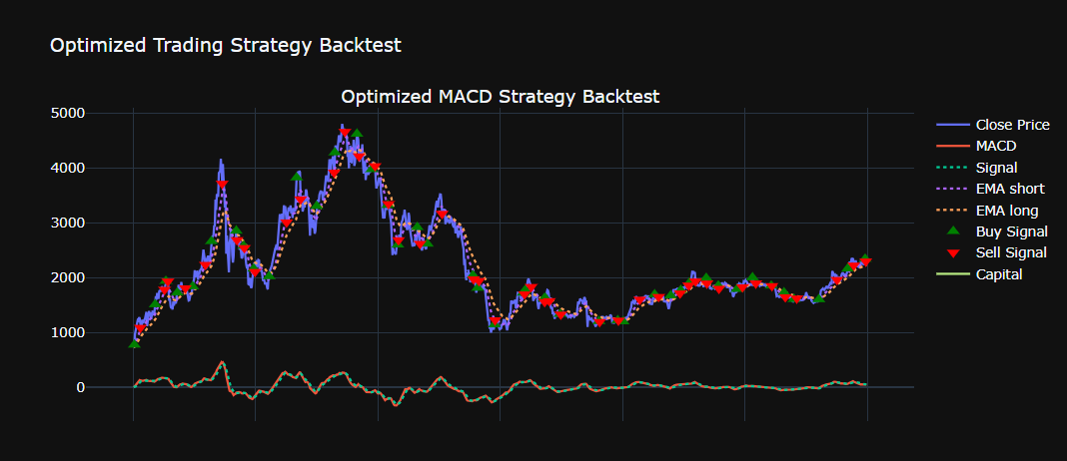

Using reinforcement learning, we find optimal parameters via best_parameters(), then fit the model for maximum profit and minimum risk, creating a robust and adaptive trading strategy.

The following are the parameters we find out work best for ETH/USDT market:

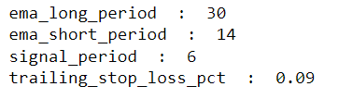

The equity curve we get after applying these parameters:

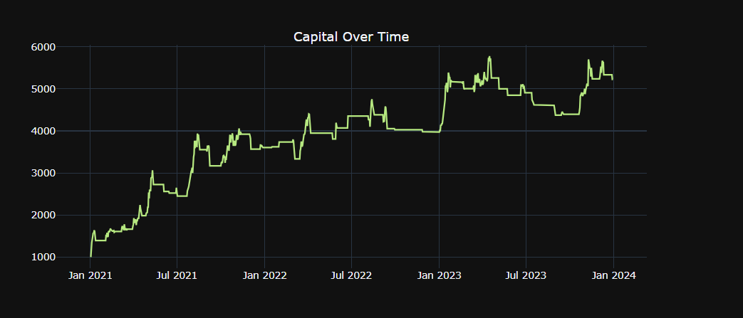

Code Logic

***Class Strategy_Macd***

**__*init*__**

The __init__ method initializes the Strategy_Macd class with the provided data. This data is stored as an instance variable for further processing by other methods in the class.

***calculate_macd***

The calculate_macd method computes the MACD (Moving Average Convergence Divergence) indicator by calculating the short-term and long-term exponential moving averages (EMA) of the close prices. It then derives the MACD line by subtracting the long-term EMA from the short-term EMA and computes the signal line as the EMA of the MACD line.

***apply_trading_strategy***

This method generates buy and sell signals based on MACD crossovers and applies a trailing stop-loss mechanism to minimize losses. It also accounts for transaction costs and maintains the trading positions. The method tracks the highest price during a trade to calculate the trailing stop-loss price and generates signals to exit the trade when the price falls below this threshold.

***best_parameters***

The best_parameters method performs a grid search to find the optimal parameters for the MACD strategy. It tests different combinations of EMA periods, signal periods, and trailing stop-loss percentages, selecting the combination that yields the highest profit. The method returns the best set of parameters.

***calculate_performance***

This method calculates various performance metrics, including total returns, net profit, win rate, maximum drawdown, annualized returns, Sharpe ratio, Sortino ratio, and average holding duration. It also identifies winning and losing trades to compute gross profit and loss.

***plot_trades***

The plot_trades method visualizes the trades by plotting the buy and sell signals, MACD, EMAs, and capital over time. It uses the Plotly library to create interactive charts that show the performance of the strategy.

***calculate_win_loss_ratio***

This method calculates the win/loss ratio by comparing the close prices on buy and sell dates. It counts the number of winning and losing trades and computes the ratio of wins to losses.

***analysis***

The analysis method applies the trading strategy using the best parameters found by the grid search. It plots the trades and prints the win/loss ratio, providing a comprehensive analysis of the strategy's performance.

***print_trades***

This method prints the buy and sell dates for each trade, allowing for a detailed review of the trade execution.

Strategy Metrics

